Annex I: Rate List for Stationery Items
S.N. | Items | Image | Unit | Unit Price
1 | Paper
A | White Offset Paper, Paper Quality: 80 GSM, Size: A4, Brand: Double A; Box of 5 Packets (01 Pack= 01 Ream); 01 RM consists of 500 Sheets of Paper |  | Box
B | White Offset Paper, Paper Quality: 80 GSM, Size: A4, Brand: Paper One; Box of 5 Packets (01 Pack= 01 Ream); 01 RM consists of 500 Sheets of Paper |  | Box
C | Multi-Colour Offset Paper, Paper Quality:80 GSM, Size: A4, Brand: Double A, Box of 5 Packets |  | Box
D | Multi-Colour Offset Paper, Paper Quality:  80 GSM, Size: A4, Brand: SINAR SPECTRA, Box of 5 Packets |  | Box
E | Brown Paper, Paper Quality: 70 GSM, Size:  29" X 44" Ream of 500 Sheets/packs |  | Each
2 | Pen
A | Gel Pen (Black, Red, Blue & Green), Brand: ................. |  | Each
B | Ball Point (Black, Blue, Red & Green) Brand:  ................. |  | Each
3 | Pencil
A | Wooden Pencil-HB (Box-Dozen), Brand: .......... |  | Dozen
4 | Pencil Cutter/ Sharpener and Eraser
A | Pencil Cutter/ Sharpener, Size: Small Brand: ................. |  | Each
B | Pencil Eraser, Brand: ................., Color: White |  | Each
5 | Marker
A | Multi-Color (Black/Blue/Red/Green) White Board Marker, Brand: .................; 12 pieces/ box |  | Box
B | Multi-Color (Black/Blue/Red/Green) Parmanent Marker, Brand: .................; 12 pieces/ box |  | Box
C | Multi-Colour Highlighter (Yellow/ Orange/  Green); Brand: .................; 10 pieces/ box |  | Box
D | Multi-Colour (Blue/Black/Green)  Permanent Marker, Brand: .................; 12 Pieces/Box |  | Box
E | Permanent Lumocolor CD/ DVD/OHP Marker, Brand: .................; 4 per set |  | Set
6 | File
A | Lever Arch File-3", Two Holes; Size: A4  Brand: ................., (Blue Colour) | 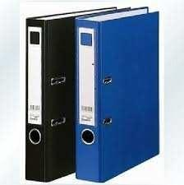 | Each
B | Lever Arch File-2", Two Holes; Size: A4  Brand: ................., (Blue Colour) |  | Each
C | Ring File-1.5", Size: A4, Brand: ................. | 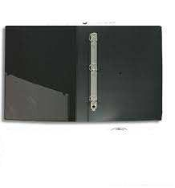 | Each
D | Clip File-1", Size: A4, Brand: ................. | 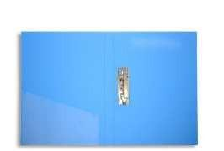 | Each
E | Transparent Plastic Management File Size:  A4, Brand: ................. | 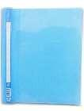 | Each
F | Plastic Made Box / Magazine File, Size: A4,  Brand: ................. |  | Each
7 | Folder
A | Multi-Colour Plastic Folder: / Seminar File/ Double Pocket reporting Folder Size: A4, P.C File, Brand: .................; Model: ................. Usuage: Easy to clip the paper or document to report. | 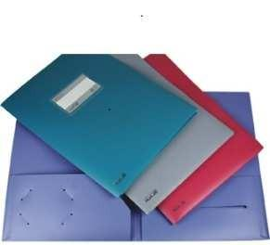 | Each
B | A4 Size My Clear Bag; Brand: ................. |  | Each
8 | Clips
A | Binder Clips - 15mm (12 pieces box) Brand: ................. |  | Box
B | Binder Clips - 19 mm (12 pieces box) Brand:  ................. |  | Box
C | Binder Clips - 25 mm (12 pieces box) Brand:  ................. |  | Box
D | Binder Clips - 32 mm (12 pieces box) Brand:  ................. |  | Box
E | Binder Clips - 41 mm (12 pieces box) Brand:  ................. |  | Box
F | Binder Clips - 51 mm (12 pieces box) Brand:  ................. |  | Box
G | Multi-Colour Gems Clip No: 625, Steel  Made, Plastic Coated (100 pieces/Box), Brand: ................. | 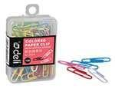 | Each
H | Multi-Colour Push Pin/ Board Pin (100  pieces/Box), Brand: ................. | 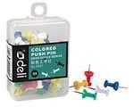 | Each
9 | Tape
A | Cello Tape; 2 Inch; 900 Gram; Transparent; Premium Quality; Brand: ................. |  | Each
B | Cello Tape Dispenser/Stand, Size: Big  Brand: ................. |  | Each
C | Masking Tape, Size: 2", Length: 20 Meter | 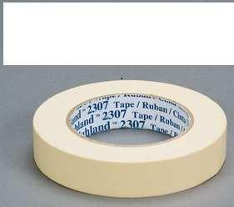 | Each
D | Cello Tape- Transparent, size: 2-1/2"  Length: 20 Meter, Any reputed brand |  | Each
E | Binding Tape/ Rexene Tape,  Size: 2" X 30 M (Rexene) Brand: Any Reputed Brand; Usuage: Book Binding | 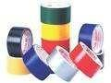 | Each
F | Binding Paper/ Transparent Plastic Paper,  Size: Fit for A4 Paper Brand: Any Reputed Brand or; Usuage: Book Binding |  | Each
G | Double Tape (Mounting Tape with Foam) |  | Each
10 | Glue Stick-Min: 21 gm, Brand: Fevi, deli or  Huajie |  | No
11 | Notebook
A | Notebook, Spiral Binding with Plastic ring.  Size: A5; Inner Page: Leaf: 40, (80 Pages) 80 GSM Offset Paper, B/w inner Print  Brand: ................. |  | No
12 | Ruler/Scale
A | Steel Ruler, Size: 12", |  | Each
B | Wooden Ruler, Size: 12", Any  reputed brand |  | Each
C | Plastic Ruler Scale, 30 cm; |  | Each
13 | File Divider, Multi Colour Plastic File  Divider, Size: A4, No: 1-10 (Packet of sheet); Brand: ................. |  | Each
14 | Staplers and Staples (Pin)
A | Stapler Machine, Size: Small, HD-10D,  Brand: .................; Stapling Capacity: 20  Sheets; |  | No
B | Stapler Machine, Size: Medium, HP-45,  Brand: .................; Stapling Capacity: 30  Sheets |  | No
C | Heavy Duty Stapler Machine, Size: Big, DS  23 S 24 ql. Brand: .................; Stapling  Capacity: 210 Sheets |  | No
D | Stapler Pin, Size: Large 24/6, (1 box =20  small packet), Brand: ................. |  | Box
E | Stapler Pin, Size: Small -10-1 M (1 box =20  small packet); Brand: ................. |  | Box
F | Stapler Pin, Size: 23/13 mm (Box with 1000  staples); Brand: ................. |  | Box
G | Stapler Pin, Size: 23/15 mm (Box with 1000  staples); Brand: ................. |  | Box
H | Stapler Pin, Size: 23/17 mm (Box with 1000  staples); Brand: ................. |  | Box
I | Stapler Pin, Size: 23/24 mm (Box with 1000  staples); Brand: ................. |  | Box
J | Stapler Pin Remover, Size: Small, SR 45,  Brand: ................. |  | No
K | Stapler Pin Remover, Size: Medium, SR  300, Brand: ................. |  | No
15 | Punch Machine
A | One Hole Punch Machine, Size: Small; Brand: .................; Punching Capacity : 10  Sheets | 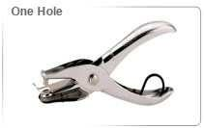 | No
B | Punch Machine, Size: Small-DP 480, Brand:  ................. |  | No
C | Punch Machine, Size: Medium- Number 88,  Brand: ................. |  | No
D | Punch Machine, Size: Large- HDP 2320,  Brand: .................; Capacity: Punching  Capacity : 290 Sheets |  | No
16 | Scissors
A | Scissors-210 mm (8 -1/4 inch) No: 6010, Brand: ................. |  | No
B | Scissors-180 mm (7 inch) Brand: ................. |  | No
17 | Whistle, Appx: 1.5" Long, Stainless Steel |  | No
18 | Calculator-12 Digit Brand: Any Reputed, Two Way Power |  | No
19 | Holder
A | Pen Holder (Metal Made) Brand: |  | No
B | Visiting Card Holder (Book) Capacity: 240Cards, Any reputed brand |  | No
20 | Post-IT
A | Stick on Pad (Post it)- Blister of 100  Sheets- 3 X 5 inch; Brand: Any reputed |  | Each
G | Index Note;/ Neon Colour Film;  Brand: Any Reputed; 5 Colour X 25 Pcs Size:  45 X 12 mm |  | Each
21 | Paper Cutter/Anti-Cutter/Knife- Standard size, Brand: Any reputed |  | No
22 | Finger Wetted Tool
A | Finger Wetted Tool-Plastic pot with sponge |  | No
23 | File/ Paper-Fastener- Plastic with 2 holes-50set per box, Brand: ................. |  | Box
24 | Cloth Duster- Standard size- Fabric made |  | No
25 | Flip Chart
A | Flip Chart Paper, Paper Quality: 60 GSM, Size: 22" X 35",Leaf: 40 |  | No
26 | Name Badges, Plastic with name Badge  Holder (ribbon) |  | No
27 | Desk Tray-1 X 3 Levels-Outward, inward,pending |  | Each
28 | Ink Colour (Black) for stamp pad-Refil, Any  Reputed |  | Each
29 | Ink Pad Black (Camlin Impression Delux Stamp pad-size 11.6cm X 6.5cm) |  | Each
30 | Register Khata, Size: Legal, Leaf: 200 |  | Each
31 | Envelope
A | Envelope (A4 Size; 70 GSM) |  | Each
B | Envelope (A5 Size; 70 GSM) |  | Each
C | Envelope (B4 Size; 70 GSM) |  | Each
32 | Camlin Carbon Papers (100 Sheets per Pack); Impress |  | Pack

Note:
- The rate quoted should be inclusive of VAT.

